Responding to the local emergence of partial artemisinin resistance in northwest Tanzania: a modelling study

Tran Dang Nguyen^{1,2}, Deus Ishengoma^{3,4}, Sarah-Blythe Ballard⁵, Robert J Zupko⁶, Carter C Farinha¹, Kien Trung Tran¹, Sarit Adhikari¹, Abdallah Lusasi⁷, Daniel A Petro¹, Chao-Yi Tsai¹, Kefas Mugittu⁸, Dunstan Bishanga⁸, Daniel Rosen⁹, Jessica Vernon⁹, Oliver J Watson¹⁰, Jonathan J Juliano¹¹, Jeff Bailey¹², Mwaka Kakolwa⁸, Sigsbert Mkude¹³, Celine Mandara⁴, Naomi Serbantez, Chonge Kitojo, Sijenunu Aron⁷, Samwel Lazaro⁷, Maciej F Boni¹

¹ Institute for Genomics and Evolutionary Medicine, Department of Biology, Temple University, Philadelphia, PA, USA
² Center for Computational Epidemiology and Infectious Diseases, Ho Chi Minh City, Vietnam
³ Ifakara Health Institute, Dar es Salaam, Tanzania
⁴ National Institute for Medical Research, Dar es Salaam, Tanzania
⁵ Department of International Health, Johns Hopkins Bloomberg School of Public Health, Johns Hopkins University, Baltimore, MD
⁶ Center for Infectious Disease Dynamics, Department of Biology, Pennsylvania State University, University Park, PA
⁷ National Malaria Control Program, Dodoma, Tanzania
⁸ Shinda Malaria Project, Ifakara Health Institute, Dar es Salaam, Tanzania
⁹ MaishaMeds Full Name, City, Country
10 Imperial
11 UNC
12 Brown
13 Dhibiti Malaria Project, Population Services International, CITY, COUNTRY

Date of this draft : Sep 28 2026

Abstract

Background. Artemisinin partial resistance has emerged in East Africa, with pfkelch13 mutations recently introduced into Kagera region in northwest Tanzania. WHO guidelines recommend deployment of multiple first-line therapies (MFT) to slow resistance. The influence of private-sector antimalarial sales on the effectiveness of resistance mitigation strategies is not known.

Methods. Using a spatially-explicit individual-based model of P. falciparum transmission and evolution model, we evaluated 86 drug-resistance mitigation strategies for Kagera, Kigoma, Geita, and Mwanza regions of northwest Tanzania. The primary outcome measure was the monthly average treatment failure count over a 6-year period. Evaluated strategies included switches of first-line therapy, MFT, cycling, triple artemisinin-based combination therapy (TACT), and Kagera-region specific strategies where the artemisinin-based combination therapy (ACT) deployed in Kagera either differed or was deployed earlier than in other regions. Each strategy was evaluated under default (47%) and low (10%) assumptions for private-sector antimalarial market share.

Results. Strategies minimizing artemether-lumefantrine (AL) use and prioritizing artesunate-amodiaquine (ASAQ) and artesunate-pyronaridine (ASPY) produced the largest reductions in treatment failures. The Pearson correlation between percentage of public-sector cases treated with AL and treatment failure count over six years was equal to 0.90 (p = 2.2 × 10⁻⁶). Assuming 47% private-sector antimalarial use, deployment of the TACT artemether-lumefantrine-amodiaquine resulted in 52.1% (90% range 50.3%-53.1%) fewer treatment failures over six years. The optimal non-TACT policy was deployment of ASAQ for four years followed by DHA-PPQ use for two years, resulting in a 41.6% (90% range: 39.5%-43.2%) reduction in treatment failures. MFT policies where half of patients were treated with ASAQ and half with ASPY resulted in a median 40.4% to 41.3% reduction in treatment failures. Reducing the private-market antimalarial share from 47% to 10% substantially increased the effectiveness of drug-resistance mitigation.

Interpretation. Drug-resistance mitigation in northwest Tanzania should prioritize ASAQ and ASPY deployment while minimizing AL use. The private-sector antimalarial market is a major determinant of mitigation policy effectiveness and must be integrated into MFT planning.

Evidence before this study

Added value of this study

Implications of all available evidence

1 Introduction

Global malaria case counts have flatlined over the past decade or shown small increases, with the 2025 WHO World Malaria Report estimating 282 million malaria cases globally for 2024 [1]. The majority of this case burden occurs in sub-Saharan Africa and is due to Plasmodium falciparum infections. Despite adoption in 2005 of artemisinin-based combination therapies (ACTs) as first-line therapy for uncomplicated falciparum malaria – with ACT coverage reaching moderate levels by 2015 [2] and high levels by the 2020s [3] – malaria incidence in sub-Saharan Africa has shown a modest decline over the past 25 years from ~350 to ~230 cases per 1000 persons at risk [1]. An additional hidden challenge is that current case counts are overwhelmingly based on public-sector treatment-seeking and reporting, missing a potentially large case burden attending private-sector pharmacies and health centers.
Compounding the challenge of slowly dropping case numbers, ACT efficacy is under threat due to the spread in East Africa of pfkelch13 mutations which are associated with higher levels of day-3 positivity [4,5] after ACT treatment and slower parasite clearance rates [5,6]. Artemether-lumefantrine (AL) treatment failure has been observed in Uganda at >15% levels in two locations [7], but this observation is not known, currently, to be linked to mutant pfkelch13 genotypes. The first known pfkelch13 mutation R561H was reported in 2020 in Rwanda with R561H parasites sampled as early as 2014 [8]. In 2021, it was reported that R561H genotypes had crossed over into Tanzania [5,9] and Kenya [10], demonstrating that P. falciparum genotypes can cross borders on a timescale of several years. Validated or candidate pfkelch13 resistance-associated mutations have been identified in 9 African countries, and the malaria community’s near-term urgent task is to determine how consequential these novel kelch variants will be for treatment failure increases across the continent.
In this analysis, we examine potential responses to the arrival of pfkelch13 R561H mutants in Kagera region in northwest Tanzania. These mutants have been sampled consistently since 2021 [5,11] and have reached local allele frequencies between 0.03 and 0.26 in Kagera region [12]. Longer parasite clearance times and a higher rate of day-3 parasite positivity after ACT treatment are associated with presence of pfkelch13 R561H mutations [5]. It is of utmost urgency to implement an anti-malarial drug-resistance (AMDR) response to mitigate potential effects locally and minimize the chance that the new mutants will spread out of the region. WHO-endorsed policies of deploying multiple first-line therapies (MFT) [13] offer a framework for AMDR-mitigation responses, but it is not known which specific MFT approach will be optimal given the current epidemiological setting and localized spread of R561H mutations in Kagera region. In this analysis, we evaluate a range of ACT deployment approaches for their ability to reduce treatment failure counts over a 6-year timeframe in northwest Tanzania. At the moment, only four ACTs – artemether-lumefantrine (AL), dihydroartemisinin-piperaquine (DHA-PPQ), artesunate-amodiaquine (ASAQ), and artesunate-pyronaridine (ASPY) – are able to be procured, and MFT strategy designs are restricted to these. In addition to traditional MFT and rotation approaches, we consider localized responses to the introduction of a single kelch variant in a single region in Tanzania. We also consider the effects of the unknown private-sector size in a rural region where treatment-seeking habits have not been specifically characterized.

2 Methods

We used an explicitly-spatial individual-based simulation model of P. falciparum transmission and evolution, whose model structure, genotype-to-phenotype drug-resistance framework, host-immunity and symptomology mechanisms, mutation process, parasite fitness costs, treatment patterns, and human movement have been described previously [14–16]. Briefly, the model was calibrated to the geography and epidemiology of four regions of northwest Tanzania: Kagera region (where R561H mutations were identified in 20xx) and the three proximate regions of Kigoma, Geita, and Mwanza. Administrative boundaries were imported from shapefiles from the Humanitarian Data Exchange [17]. Population density raster data for 2020 were downloaded from WorldPop [18] on a 1km-by-1km (30 arcseconds) scale and re-scaled to a 5km-by-5km raster, resulting in a total of 4102 pixels. Human movement patterns, for both adults and children, were calibrated so that the probability of movement between regions in a 60-day period was 4.3%; this is approximately half the rate of human movement used in our previous modeling analysis for Uganda [16] reflecting northwest Tanzania’s rural nature and low population density. Malaria prevalence data were downloaded from the Malaria Atlas Project [19] at 5km-by-5km resolution, and the model’s transmission rate (the mosquito biting rate) was calibrated to match each 5km-by-5km pixel’s blood-slide prevalence in 2-10 year-olds (PfPR₂₋₁₀) as described previously [16]. Treatment seeking and antimalarial preference survey data were obtained from demographic health surveys (DHS) [20–23]. Public-sector incidence data for 2023 were obtained directly from Tanzania’s National Malaria Control Program (NMCP) as 117 reported malaria cases per 1000 individuals for Kagera region, 107/1000 for Kigoma, 98/1000 for Mwanza, and 114/1000 for Geita region.
Monthly malaria case data consisting of absolute counts of RDT-positive reported cases were collected in the Kagera (KAG) region of Tanzania over the period 2017–2023 [24]. The model’s daily transmission pattern was fit to the monthly average case count in Kagera region over this period, by normalizing the case counts to an annual mean and using a relative transmission intensity quantity for different times of year. Details are provided in Supplementary Section S1.1, and the resulting seasonal transmission calibration is shown in Supplementary Figure 1.
Two versions of the model were calibrated, one where 10% of treated malaria cases are treated in private-sector pharmacies or clinics (data based on NMCP observation) and one where 47% of treated cases are treated in the private sector (based on DHS survey responses). In the 47% private-sector model, transmission was scaled down by factors of 0.7 (Kigoma and Kagera) and 0.8 (Mwanza and Geita), resulting in an average PfPR₂₋₁₀ = 4.5% across all four regions and an annual incidence of 124 cases per 1000. The 10% private-sector model required more adjustment and the calibrated transmission parameters were scaled down by 0.40 (Kigoma), 0.45 (Kagera), 0.65 (Mwanza), and 0.50 (Geita) from their original levels resulting in a region-wide average PfPR₂₋₁₀ of 2.7% and an annual incidence of 116 cases per 1000 individuals. The newly-calibrated prevalence levels are lower than the estimated regionwide 9.8% average PfPR₂₋₁₀ [19]. The spatial calibration of simulated PfPR2–10 against Malaria Atlas Project estimates is shown in Supplementary Figure 2. The decision to calibrate more closely to incidence over prevalence came from NMCP’s higher confidence in public-sector case counts than in local prevalence estimates for northwest Tanzania. As in past model calibration exercises, the model generates more cases than should be observed for a given prevalence level; see Discussion for potential causes.

2.1 Model initialization and simulation timeline

Public-sector antimalarial drug usage in the model was assumed to be 100% AL. From DHS data, private-sector drug preference was set to 78% AL, 13% sulfadoxine-pyrimethamine (SP), 6% DHA-PPQ, 2% quinine, and 1% ASAQ, although higher levels of SP use have been reported [25]. Model simulations begin with a burn-in period starting January 1, 2003. The mutation process was activated on January 1, 2018, with a mutation probability of 0.001983 per treatment based on past calibrations [26,27]. Baseline allele frequencies for resistance-associated loci were initialized in 2003 at 0.015 for pfcrt 76T and 0.02 for pfmdr1 86Y. These initial frequencies were calibrated so that simulated allele-frequency trajectories were consistent with the available molecular-marker data from Tanzania [28–31], with the primary calibration selected to visually approximate the observed data points. Under this calibration, simulated allele frequencies in 2025 were approximately 0.08 for pfcrt 76T and 0.05 for pfmdr1 86Y. An alternative low-frequency calibration was also generated, producing 2025 frequencies of approximately 0.05 for pfcrt 76T and 0.01 for pfmdr1 86Y. Full calibration details for all six loci tracked in the simulation is described in Supplementary Section S1.4. A second baseline set of allele frequencies was considered as a sensitivity analysis; see Supplementary Materials. This alternative baseline was used as a sensitivity analysis. Full calibration details for all resistance-associated loci tracked in the simulation, under both the primary and alternative baseline-frequency scenarios, are provided in Supplementary Section S1.4 and Supplementary Figures 3–6.
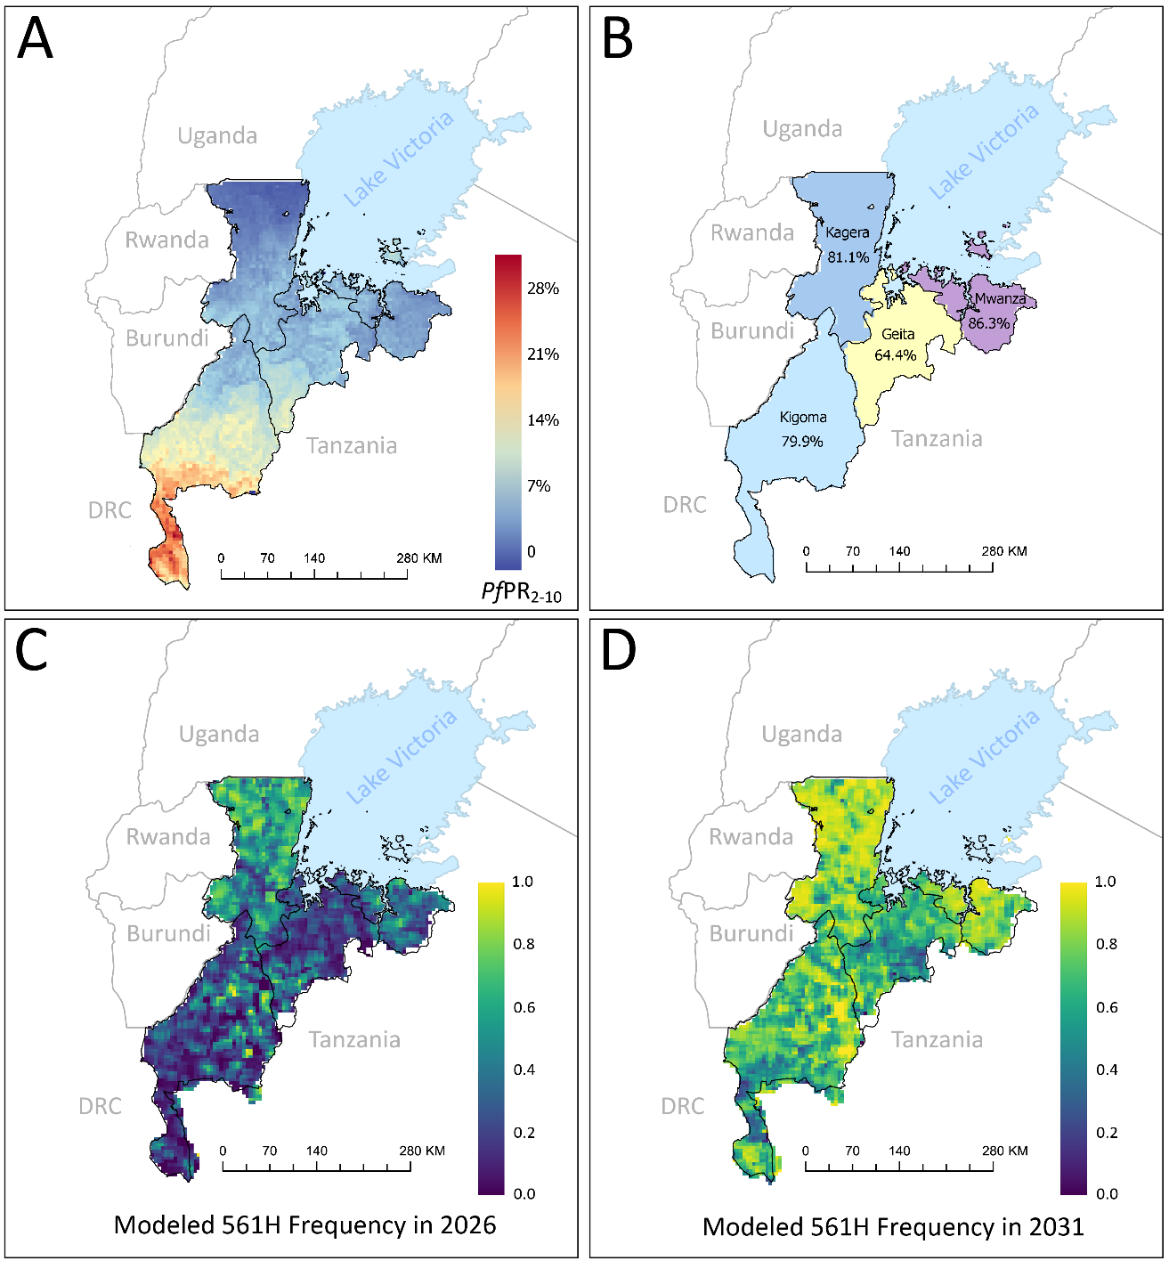

Figure 1. (A) Four northwest regions of Tanzania are shown with prevalence in 2-10 year-olds (PfPR₂₋₁₀) on a 5km-by-5km pixel scale. data points on pfkelch13 561H frequency in Kagera region (red circles, panel A). (B) Four northwest regions of Tanzania are labelled and color-coded with their 202x treatment coverage estimates, as taken from demographic health survey responses on whether treatment was sought for a fever in an under-5 member of a household. (C) Model projections of median allele frequency of pfkelch13 561H in 2026, following 3×3 neighborhood smoothing to reduce cell-level variability arising from small local population and infection counts. (D) Model projections of median allele frequency of pfkelch13 561H in 2031, following 3×3 neighborhood smoothing to reduce cell-level variability arising from small local population and infection counts.
2.2 Intervention strategies

Interventions strategies to delay and slow the spread of drug-resistant genotypes were set in the model to begin on January 1, 2026 and were evaluated through January 1, 2032. Evaluated strategies included: (1) switches to a different single first-line ACT, (2) delayed switches to a different single first-line ACT by 1 to 4 years, (3) deployment of the triple ACT (TACT) artemether-lumefantrine-amodiaquine (ALAQ), (4) delayed deployment of ALAQ with an interim strategy of deploying other ACTs in the public sector, (5) MFT deployment with various percentages of the population receiving different ACTs, (6) ACT rotation periods lasting 1, 2, 3, or 4 years, (7) a first-line switch in Kagera region to one ACT and a first-line switch in the other regions to a different ACT, and (8) a first-line switch in Kagera region first and a delayed switch in other regions by 1 or 2 years. ACT policy changes under these strategies were implemented in the model in the public sector only. These 8 categories comprised 87 unique ACT deployment strategies. Some deduplication of strategic approaches was necessary as, for example, a 3-year delay followed by introduction of ASAQ is the same strategy as a 3-year rotation strategy that deploys AL first and ASAQ second.
The analysis included four ACTs: AL, ASAQ, DHA-PPQ, and ASPY. Because the clinical efficacy of ASPY against parasites carrying both pfkelch13-mediated artemisinin resistance and pyronaridine resistance is not known, ASPY-containing strategies were evaluated under three hypothetical scenarios in which treatment efficacy against these double-resistant genotypes was assumed to be 65%, 75%, or 85%. ASPY in these strategies is labelled as ASPY65, ASPY75, and ASPY85, respectively.

2.3 Outcomes and statistical summaries

Model outcomes were evaluated over the six-year intervention period from January 1, 2026, to January 1, 2032. The main reported outcome is the average monthly number of (non-discounted) treatment failures, summed across Kagera, Kigoma, Geita, and Mwanza regions and averaged over the six-year evaluation period. Treatment failure counts are summarized across stochastic simulation replicates by reporting the median, interquartile ranges, and 90% ranges of simulation outcomes. Secondary reported outcomes include the relative reduction in treatment failure counts compared with the status quo and the frequency of pfkelch13 resistance alleles at the end of the intervention period.

3 Results

An individual-based malaria model was calibrated to Kagera, Kigoma, Mwanza, and Geita regions of northwest Tanzania to match malaria prevalence levels at 5km-by-5km resolution and malaria incidence at region level. The model’s average prevalence in 2025 across all four regions is 4.5%, and the average annual reported malaria incidence is 126 cases per thousand individuals. Four baseline epidemiological scenarios were calibrated and tested allowing for variation in the percentage of all antimalarial treatment seeking that occurs in the private sector (47% versus 10%) and allowing for lower or higher allele frequencies of certain key alleles known to influence the efficacy of the partner drugs lumefantrine and amodiaquine. The primary baseline scenario presented for most analyses, unless otherwise stated, assumes that 47% of antimalarial treatment seeking occurs in the private market and that the 2025 allele frequencies of pfcrt 76T and pfmdr1 86Y are 0.08 and 0.05, respectively.
Continuing status quo treatment policy, in which artemether-lumefantrine is recommended as first-line therapy for all uncomplicated falciparum malaria, the model projects an average of 46,768 (90% range: 44,972 – 49,124) treatment failures per month combined across all four regions, over the six years from Jan 1 2026 to Jan 1 2032, under a scenario where 47% of all antimalarial treatments are purchased in the private sector; under a 10% private-market scenario the projected monthly treatment failure average is 27,140 (90% range 22,572 – 35,862). The higher treatment failure count under the 47% private-sector treatment-seeking scenario results from a 4.7-fold increase (when compared to the 10% private-sector scenario) in non-ACT therapies used to treat uncomplicated falciparum malaria cases. This underlines the importance of knowing the volume of total private-market antimalarial sales as larger public-sector involvement in malaria case management is associated with lower case counts and higher average treatment efficacy. A change in first-line therapy to ASAQ on Jan 1 2026 results in a model-projected 27,620 treatment failures per month (90% range 26,893 - 28,289) averaged over the six years from Jan 1 2026 to Jan 1 2032, assuming 47% of treatment are in the private sector. Under these same conditions, a change in first-line therapy to DHA-PPQ results in a median 39,910 monthly treatment failures (90% range 38,318- 41,775) as model projections indicate that partner-drug resistance evolution would be faster under DHA-PPQ use than under ASAQ use. Note that model-projected treatment failure counts and percentages are presented for the entire 10.5M population of these four regions averaged across all therapies used by patients.
As in most evaluations of long-term stewardship of antimicrobial drugs, therapeutic diversification plays a key role in preserving and extending the useful therapeutic life of the deployed therapies [32,33]. Figure 2 shows that diversifying away from AL – the dominant ACT used in Tanzania for the past 20 years – via a rotational or an MFT strategy reduces the projected number of treatment failures with some reductions exceeding 40%. The optimal MFT option is a deployment where 75% of patients are treated with ASAQ and 25% of with DHA-PPQ, resulting in a projected 27,439 (90% range: 26,757 – 28,193) treatment failures per month – a 41.3% reduction in treatment failures over six years. The optimal 2-year cycling option is a rotation with ASAQ used first, DHA-PPQ used in years 3 and 4, and ASAQ used again in years 5 and 6. This amounts to 67% of patients during this time period being treated with ASAQ and 33% being treated with DHA-PPQ, corresponding to 27,748 treatment failures per month (90% range: 26,866 - 28,422) or a 40.7% reduction compared to status quo AL use. The reason is that ASAQ is projected to have high efficacy on currently circulating genotypes, corroborated by both genetic analyses [34,35] and recent therapeutic efficacy studies [7,36,37]. Representative treatment-failure trajectories for delayed switching, cycling, MFT, and triple ACT strategies are shown in Supplementary Figure 16.

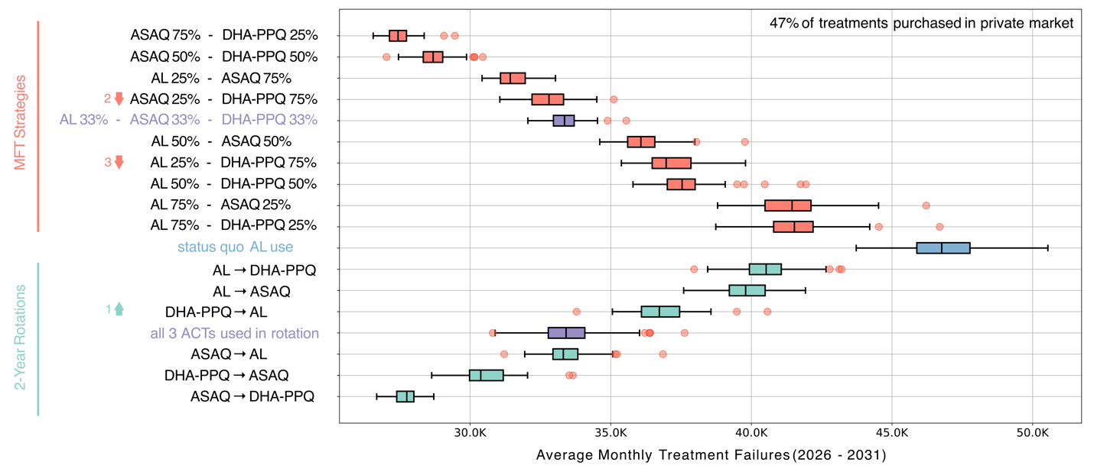
Figure 2. Treatment strategy comparisons for standard cycling and MFT approaches. Status quo use of AL as first-line therapy is shown in blue, and the projected monthly average of treatment failure counts, summed over all four regions, averaged over six years, is shown as a box plot. Box-plot whiskers show 1.5 IQR and red circles show outliers from the 100 simulations summarized by each boxplot. MFT approaches are shown above and 2-year rotation approaches are shown below the status quo strategy; the strategies are sorted by their projected treatment failure average. The strategy at bottom labelled “ASAQ → DHA-PPQ” represents a cycling approach where ASAQ is used for 2 years, then DHA-PPQ for 2 years, then ASAQ again for 2 years; i.e. in these cycling strategies the first ACT listed is used for four years and the second one is used for two years. The cycling strategy where all three ACTs are used summarizes 600 simulations over all six possible orderings of these ACTs; the ordering does not have a large effect on average treatment failure count. Three strategies (marked by up/down arrows) have worse rankings when the simulation scenario is changed to 10% private market use. These strategies (all with high DHA-PPQ use) move 1, 2, or 3 ranks down as their treatment failure count gets higher when DHA-PPQ usage in the population expands as a result of 90% public-sector treatment seeking.

In this analysis, the cycling and MFT strategies representing the most even or most uniform diversification (purple boxes, Figure 2) are not the ones that minimize treatment failures. An MFT strategy with all three ACTs used in equal amounts lowers the treatment failure count by a median 28.7% (90% range: 26.6% - 30.7%) while the median cycling strategy using all three ACTs (in any order) reduces the treatment failure count by 28.6% (90% range: 24.9% - 31.3%). The reason for these approaches’ sub-optimality is that they include AL as part of the diversification, and 20 years of AL use in Tanzania has selected for P. falciparum genotypes on which AL efficacy is projected to be low [38].
Across all 87 evaluated scenarios, there was a clear positive correlation between the absolute number of AL courses used to treat malaria cases and the projected treatment failure counts over six years (Pearson ρ = 0.90; p < 2 x 10⁻¹⁶). Figure 3 shows all strategies grouped by the fraction of malaria patients, over all six years, that would be treated by AL in these scenarios. Note that with 47% of patients seeking treatment in the private sector and 78% of private-sector antimalarial usage being AL, the percentages of real-world AL use under these strategies range from 36.7% (the minimum amount based on private sector sales) to 89.7% under status quo conditions. Minimum AL usage approaches are associated with 25,000 to 30,000 projected treatment failures per month, with a simple first-line switch to DHA-PPQ as the only exception to this rule (39,910 monthly treatment failures). As in previous modeling exercises [26,39,40] the risk of double-resistance evolution to both components of DHA-PPQ is associated with a higher treatment failure percentage than double-resistance to AL or ASAQ, based on clinical data from southeast Asia [41–43]. Strategies where >70% of malaria cases are treated with AL are projected to result in 35,000 to 50,000 treatment failures per month. Supplementary Figures 7-9 show that this correlation holds in all four scenarios evaluated.

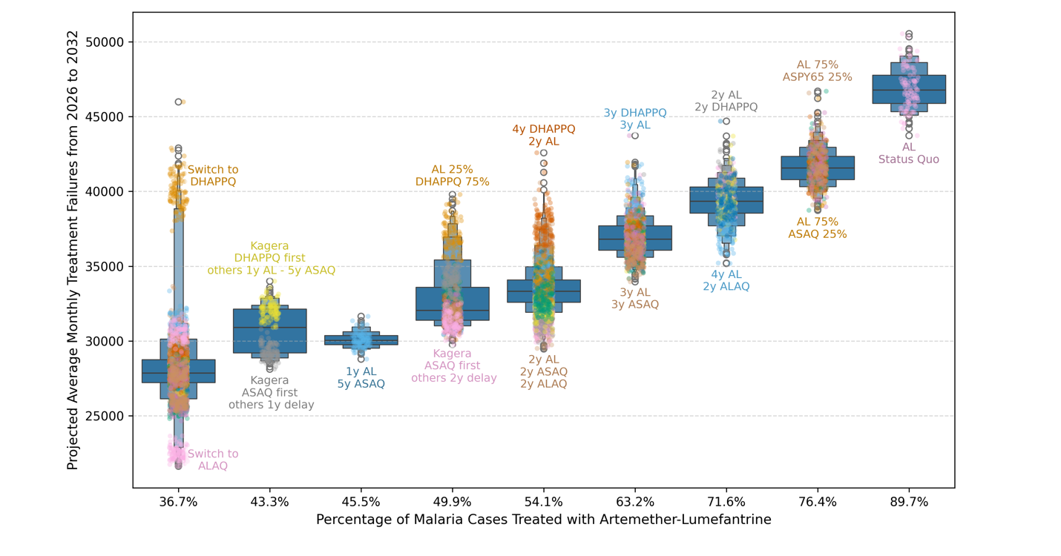
Figure 3. Relationship between population-level use of artemether-lumefantrine (AL) and monthly treatment failures under a 47% private-market scenario. Each letter-value boxplot summarizes treatment failure outcomes from 2026 to 2032 across simulated strategies with the same average percentage of malaria cases treated with AL in the total population (including both public- and private-sector treatment). Jittered points represent individual simulation outcomes and are overlaid on the boxplots, with colors distinguishing intervention scenarios, some of which are labelled with color-matched labels. Treatment failures increase as population-level AL use rises, with the lowest treatment failure counts occurring among strategies with 36.7% AL use, including a full switch to ALAQ or a full switch to DHA-PPQ, and the highest counts occurring under continued AL use in the status quo, where 89.7% of malaria cases are treated with AL. Selected annotations identify representative low- and high-performing strategies within each AL-use category. Results show a strong positive correlation between AL use and projected treatment failure burden (Pearson ρ = 0.90, p < 2.2×10⁻¹⁶), indicating that greater reliance on AL is consistently associated with higher treatment failures across simulated policy configurations.

__________

Effects of private-sector treatment seeking. Reducing reliance on the private sector for first-line antimalarial treatment improves the effectiveness of drug-resistance management strategies. For 85 out of 86 strategies tested, reducing the amount of private market treatment from 47% to 10% resulted in improvement in a strategy’s ability to reduce treatment failure counts. The magnitude of the improvement (width of light blue bars in Figure 4A) is projected to be between 4% and 35%. The reason is that current private-sector treatment has high built-in preference for artemether-lumefantrine (self-reported at 78%), and reducing the role of the private sector in malaria treatment helps reduce the overall usage of AL in the population. The strategy evaluations assume that private-sector AL preferences stay constant after a change in national policy. The exception to this rule occurred for policies involving substantial DHA-PPQ deployment. When the chosen public-sector policy involves substantial deployment of DHA-PPQ (>66% of cases) determining the appropriate levels or public-sector and private-sector treatment must balance the risk of additional AL use (current treatment failure risk) and the long-term risk of overusing DHA-PPQ (future treatment failure risk). Moving these DHA-PPQ-centered policies (black-colored bars in Figure 4A) to a scenario with a larger public-sector role results in additional 4% to 15% reductions in treatment failures when compared with the status quo; in other words, the benefit of expanding the public sector is smallest for DHA-PPQ-centered policies. Across all evaluated strategies, a shift to higher public-sector use is also projected to slow down the spread of pfkelch13 alleles over the six-year period evaluated here (Figure 4B). The same overall pattern was observed under the lower pfcrt 76T and pfmdr1 86Y baseline-frequency scenario (Supplementary Figure 10).
Deployment of novel therapies. ASPY deployments were considered assuming ASPY supply would be low (available for a maximum 50% of treatments) and three hypothetical pyronaridine-resistant phenotypes were considered that lowered ASPY efficacy on double-resistant genotypes to 85%, 75%, or 65%. Adding ASPY to an MFT strategy with ASAQ only, or to a 3 ACT MFT policy deploying ASPY, ASAQ, and DHA-PPQ leads to the same beneficial effects as the best rotational or MFT policies seen in Figure 2. These strategies resulted in an approximate average of 27,601 treatment failures per month (depending on the exact policy chosen) and near-optimal 40.4% to 41.3% reductions in treatment failure over six years. Assuming de novo mutation rates similar to those of other drug-resistance mutations, pyronaridine resistance does not evolve to high levels over a 6-year period when ASPY is used for fewer than 50% of malaria cases (Supplementary Figures 11-12). The largest near-term reduction in treatment failures was projected under deployment of the triple ACT artemether–lumefantrine–amodiaquine (ALAQ). Consistent with previous analyses in past analyses for Rwanda [15] and Uganda [16], ALAQ produced a monthly average of 22,409 (90% range: 21,940 – 23,267) monthly treatment failures, a 52.1% reduction compared to status quo and the lowest projected failure burden among all evaluated strategies. Representative genotype-frequency trajectories under continued AL use, immediate ASAQ deployment, and immediate ALAQ deployment are shown in Supplementary Figure 17.
Region-specific approaches and delayed roll-outs. Five strategies were evaluated where ASAQ or DHA-PPQ was deployed in Kagera region first (current focal point of pfkelch13 spread in Tanzania) and either a different ACT or delayed deployment of the same ACT were planned for the other three regions. Consistent with a previous analysis on stepwise regional distribution [44], there did not appear to be any benefit to this geographically-managed approach of deploying new ACTs. Delays in deploying drug-resistance mitigation strategies are generally detrimental. Figure 5 shows the accumulation of additional treatment failures and a faster pace of pfkelch13 evolution when a switch from AL to ASAQ is delayed by up to four years. A one-year delay increased treatment failures by approximately 8.8% relative to immediate ASAQ deployment, while a two-year delay increased failures by approximately 18.1%. The same qualitative effect of delayed ASAQ deployment was observed under the alternative private-market and baseline resistance-frequency scenarios (Supplementary Figures 13–15). Delays in triple ACT deployment were likewise detrimental (top four rows of Figure 4A). Staggered or delayed rollouts of new therapies may offer a potential operational or financial advantage but no quantifiable health benefits in reducing future treatment failures.

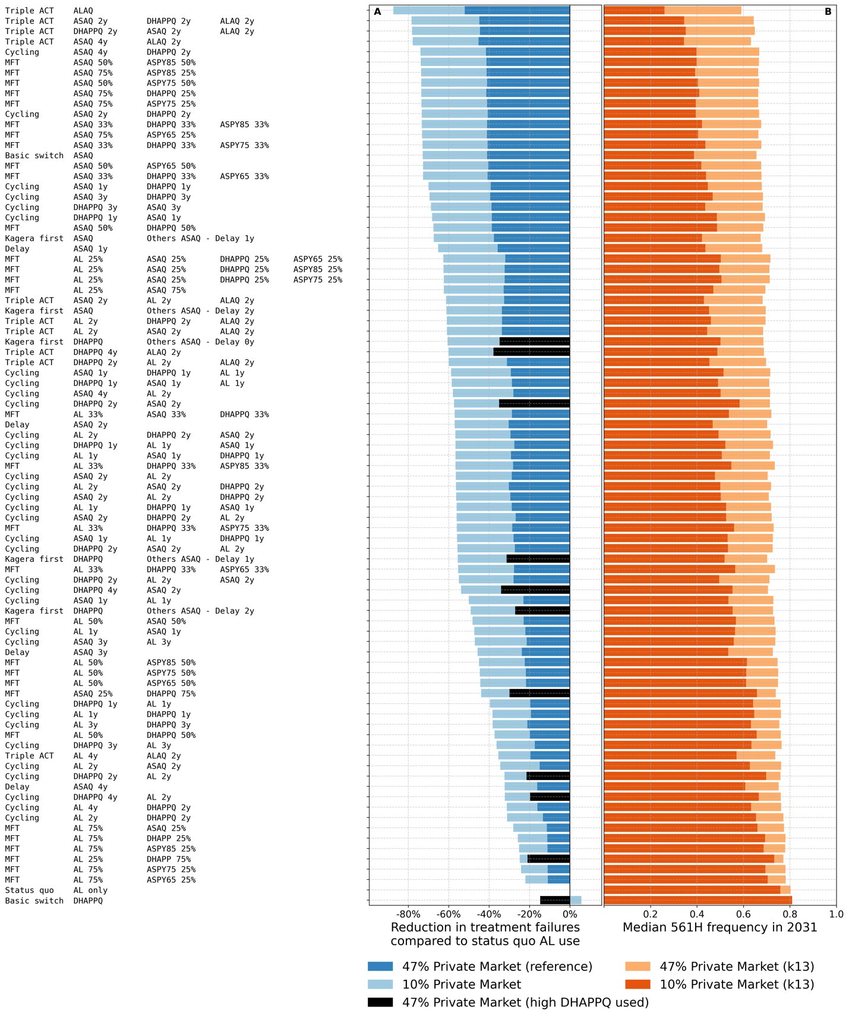Figure 4. Comparative impact of private-sector market reduction on (A) projected six-year treatment failure counts and (B) pfkelch13 allele frequency, across all considered 87 ACT deployment scenarios. Each row represents one of the 87 evaluated ACT deployment strategies. The first column of the text labels on the left-hand side identifies each strategy as one of “Triple ACT”, “Cycling”, “MFT”, “Basic Switch”, “Kagera First”, and “Delay”. The subsequent columns of text labels show either the order or cycling, the order of delay/deployment, or the proportional use of ACTs in an MFT approach. As an example, the second row corresponds to a triple ACT deployment where ASAQ is used first for 2 years, then DHA-PPQ is used for 2 years, after which the triple ACT becomes available and is deployed. The 23rd row shows a “Kagera First” strategy where ASAQ is deployed in Kagera region immediately, and in the other three regions with a 1-year delay. In panel A, dark blue and black horizontal bars show, for the 47% private-sector market share scenario, the relative change in average treatment failure counts over six years when comparing to status quo AL use. The light-blue bars show, for each strategy, the relative reduction in treatment failures under a 10% private-sector market share scenario (with baseline for comparison being AL use under 10% private-sector treatment seeking). Scenarios are ordered by descending effectiveness under the 10% private-sector market-share scenario. Reductions in private-sector antimalarial use amplify the effectiveness of most ACT deployment strategies, with the exception of a full switch to DHA-PPQ which shows worse performance when public-sector malaria treatment is larger. In panel B, paired horizontal bars show each strategy’s corresponding pfkelch13 allele frequency in 2031 under 47% private-sector antimalarial use (dark orange bar) and 10% private-sector antimalarial use (light orange bar). Annotations indicating the difference in pfkelch13 frequency under these two scenarios. Results highlight that restricting private-sector ACT use can substantially reduce treatment failures across most deployment strategies and is also associated with lower pfkelch13 allele frequencies in 2031.

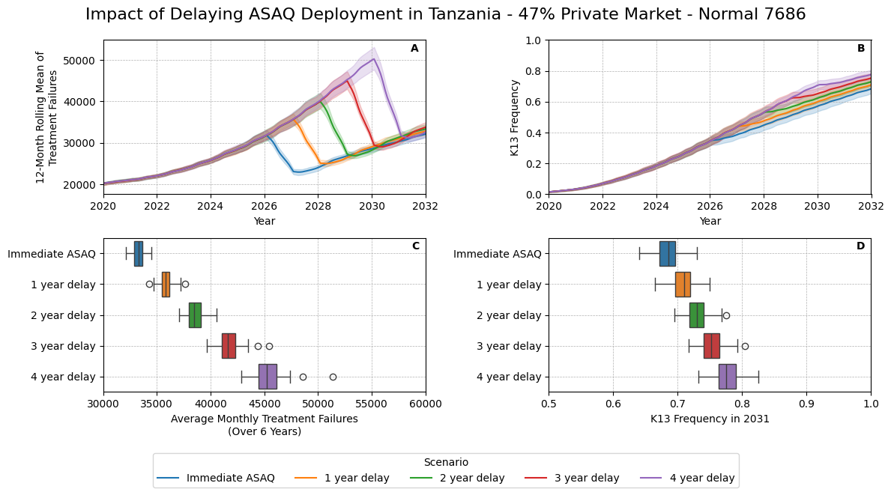

Figure 5. Effect of delayed ASAQ adoption on treatment failures and pfkelch13 allele frequency in Tanzania under 47% private-sector treatment seeking. Scenarios compare immediate deployment of artesunate-amodiaquine (ASAQ) to 1-, 2-, 3-, and 4-year delays before ASAQ adoption. Top panels show annual trends from 2020 to 2032 for (A) projected treatment failures and (B) pfkelch13 allele frequency, with colors indicating the timing of ASAQ deployment. Bottom panels summarize six-year outcomes after Jan 2026, showing (C) average monthly treatment failures and (D) pfkelch13 frequency in 2031 for each delay scenario. A one-year delay increases treatment failures by approximately 8.8% relative to immediate ASAQ deployment, while a two-year delay increases failures by approximately 18.1%.

4 Discussion

When evaluating long-term approaches to drug-resistance mitigation, diversification of antimalarial therapies has the strongest rationale as the basis for an approach to delaying and slowing the evolution of drug resistance. Diversification can either be done at the population level with different individuals receiving different therapies [13,32] or at an individual level with combination therapy aiming to prevent the emergence of novel resistant genotypes during treatment [40,45]. In the near term or medium term, certain therapies may be projected/estimated to have higher efficacy than others, and an optimal response plan to the emergence of a particular type of resistance may lean more heavily towards the use of one type of treatment than another, resulting in a near-term distribution of treatments that is not maximally diverse. As the past twenty years of malaria treatment in Africa have not been intentionally diversified, with most countries recommending and deploying artemether-lumefantrine at large scale, a critical step in current ACT diversification effort requires removing the most widely used therapies from circulation and prioritizing deployment of the remaining ACTs. The modeling analysis carried out here for the four northwest regions of Tanzania confirms that any strategy aiming to reduce future treatment failure counts (over the next 6 years) should rely most heavily on deployment of artesunate-amodiaquine and artesunate-pyronaridine. This is consistent with modeling projections for Rwanda [15], Uganda [16], and Burkina Faso [14].
Unlike the responses in Rwanda and Uganda, an AMDR response in Tanzania can be appropriately designed as a localized response centered on the point of geographic introduction of a novel kelch allele. Nevertheless, the modeling did not show any benefit (in terms of reducing treatment failures or slowing the advance of kelch alleles) for strategies that prioritize ACT deployment in Kagera first or that assign a different ACT to Kagera than to the other three regions. The reason is that ASAQ is projected to outperform AL in all four regions, not just Kagera, leaving little room for a differentiated regional strategy. Moreover, inferred patterns of human movement suggest that kelch alleles will soon spread or have already spread to Kigoma, Geita, and Mwanza regions. A localized approach focusing on drug-resistance mitigation in Kagera region first may bring operational convenience or reduced initial cost, but the public health benefits are projected to be similar to approaches that are uniform across all four regions.
As deployment of ASAQ and ASPY is projected to result in a substantial lowering of treatment failures over the next six years, a reasonable approach to national-level drug-resistance mitigation in Tanzania is to deploy ASAQ as first-line therapy during a transition period (e.g. 4 to 6 years) and then design subsequent plans to deploy additional ACTs, a triple ACT, or the non-ACT therapy ganaplacide-lumefantrine [46]. This ensures high treatment efficacy for a number of years, while long-term management plans are evaluated based on cost, availability, and the desired simplicity or complexity of malaria treatment guidelines. ASPY is an equally viable candidate as a transition therapy while MFT and drug-resistance mitigation plans are finalized, but the feasibility of this approach may be precluded by current cost and supply of ASPY.
The key novel question posed and addressed in this analysis is whether the size of private-sector antimalarial sales influences the effectiveness of AMDR mitigation strategies. The modeling results show that a high volume of private-sector antimalarial sales prevents an AMDR-mitigation policy from reaching all areas where malaria treatment of self-treatment takes place. Therefore, if the intent of a policy is withdrawal or reduction in use of a particular therapy (e.g. AL) but private-sector use of this therapy continues, the drug-resistance mitigation effect is weakened as the withdrawal of this particular therapy becomes partial. Under our default assumption that 47% of antimalarial purchases are made in the private market, the optimal 2-year rotation policy of ASAQ followed by DHA-PPQ results in a 40.7% reduction in treatment failures over six years; under a 10% private-sector size, the treatment failure reduction of this same cycling policy is 73.3%. For the optimal MFT strategy of 50% ASAQ use and 50% ASPY use, the treatment failure reductions over six years are 41.3% (with a 47% private-sector) and 73.9% (with a 10% private-sector).
Depending on the size of the private-sector antimalarial market and the preferences shown by health providers and patients, three options are available to integrate private-sector prescribing into an AMDR mitigation policy. First, the private sector could be persuaded or required to follow national treatment guidelines. Compliance would vary widely across countries and health systems. Second, private-sector antimalarial sales volume could be made smaller via regulations on who can prescribe certain drugs or an expansion of public-sector facilities providing free or subsidized antimalarial treatments. Third, for an unmovable private sector, the sales patterns in private pharmacies and clinics can be integrated into an MFT policy under the assumption that all districts, towns, and villages have access to both public-sector and private-sector facilities. Under this scenario, private-sector sales are viewed as part of an overall diversification strategy and public-sector choices are made to balance current sales patterns and preferences in the private sector. As an example, in our previous modeling analysis for Uganda, a large private-sector presence and strong patient preference for AL resulted in (1) a narrowing of optimal public-sector choices to MFT and cycling approaches that deployed ASAQ and DHA-PPQ, and (2) a projected on-the-ground drug diversification where patients in the same localities would purchase one ACT in a private pharmacy but would be prescribed a different ACT at a public clinic. This public/private mixing of ACTs ensures that parasites are exposed to both partner drugs in a short time period and small geographical range. Results from the present analysis on northwest Tanzania support this as a viable and effective approach to balancing ACT distribution across public and private markets; the optimal public-sector strategies are those that minimize AL use (Figure 2).
Our analysis has several limitations. First, despite 20 years of improved surveillance, malaria case numbers are still difficult to estimate in Africa due to (1) sub-clinical cases in adults that are untreated, partially treated, or unreported, (2) self-treatment, (3) incomplete penetration of centralized reporting infrastructure for public-sector facilities, and (4) private-sector care-seeking that is partially reported through DHIS2 systems but only for some facilities in some regions. While NMCP Tanzania is confident in the estimated 100-115 annual malaria case incidence per 1000 population in northwest Tanzania, this would mean that the prevalence in this region could potentially be higher than 10% PfPR₂₋₁₀ according to the pre-ACT era data on prevalence and incidence in Tanzania [47]. Modern estimates place average prevalence in northwest Tanzania at 9.8% for 2-10 year-olds [19] and between 4% and 13% for the under-five age group [23]. In our modeling scenario of 10% private-sector antimalarial sales, ACT coverage of malaria cases is high and model prevalence settles to less than 3% prevalence in 2-10 year-olds, an unlikely model fit given current prevalence estimates. This suggests that the 47% private-sector purchasing assumption is more consistent with contemporary epidemiological data for northwest Tanzania.
Second, treatment failures have not yet begun to increase in any African region reporting novel pfkelch13 mutations. Note that model-projected treatment failure counts include events across all therapies and all treatment sectors, including symptomatic malaria infections that remain unreported. Typical field-based estimates of treatment failure come from therapeutic efficacy studies (TES). These are run periodically, every one to two years, and it would take at least several years to detect a change in treatment efficacy in the same region. Thus, the absence of a clear rise in reported treatment failures does not necessarily mean that ACT efficacy is unchanged. Treatment failure reports are not included in routine data collection, an omission that should be the focus of dedicated and creative surveillance planning to determine whether it is feasible to incorporate a basic mechanism for detecting treatment failures in routine data [48]. Without this, a significant decline in ACT efficacy could go unnoticed until it is too difficult to reverse.
Third, substantial uncertainty will likely remain on the future evolution of piperaquine resistance and pyronaridine resistance. In a past analysis for Burkina Faso as well as the present analysis, deployment of ASPY is favored even in the absence of any knowledge on future treatment failure percentages for (hypothetical) P. falciparum genotypes that are double-resistant to ASPY. Under the assumption that treatment efficacy for an ASPY double-resistant could drop to the 65% to 85% range, current model evaluations still support joint ASAQ and ASPY deployment as one of the most effective approaches to lowering treatment failure counts and slowing pfkelch13 evolution over the next six years. As the assumed treatment efficacy of ASPY on double-resistant genotypes drops from 85% to 75% to 65%, modeling analyses show that the projected monthly treatment failure average only increases from 27,464 to 27,615 to 27,865 under a 50-50 MFT deployment of ASAQ and ASPY (median values, see Supplementary Table 1). As discussed in several previous analyses [14–16,49] the future evolution of piperaquine in resistance in Africa is unknown, difficult to predict, and far more consequential to future treatment failure counts. Efficacy studies from Cambodia showed 25% to 42% treatment efficacy of DHA-PPQ on artemisinin-resistant piperaquine-resistant falciparum genotypes [43,50].
WHO guidelines on deployment of multiple first-line therapies [13] represent an essential framework for coordinating the global response to antimalarial drug resistance. The analyses presented here – together with earlier country-specific analyses for Rwanda, Uganda, and Burkina Faso – underscore that effective implementation of these guidelines will sometimes require country-by-country adaptation. Two factors vary substantially across African settings and preclude a one-size-fits-all approach. The first is the past history and coverage of antimalarial drug use which continues to influence the genetic structure of P. falciparum alleles, pfkelch13 and others, currently circulating in country. The second is the starting set of implementation options for AMDR mitigation. This varies according to operational feasibility of various MFT and cycling strategies, procurement and supply-chain complexity, private-sector market structure, and regional presence of seasonal malaria chemoprevention programs. Together, these two factors mean that while the logic of treatment diversification can be universally applied, the specific combination of therapies, the timing of deployment, and the sequencing of policy changes must be tailored to each country's epidemiological, genetic, and operational context.

Supplementary appendix
The supplementary appendix provides additional details on model calibration, epidemiological and molecular-marker inputs, intervention scenario definitions, sensitivity analyses, and supplementary tables and figures showing treatment-failure and resistance-allele trajectories across the evaluated scenarios.

Contributors
TDN, DI, SAron, SL, and MFB conceptualized the study. RJZ, CCF, C-YT, MFB performed initial model calibration. TDN, RJZ, CCF, KTT, SAdhikari, DAP, and C-YT contributed to model development, simulation, or computational analyses. TDN performed the primary analyses and visualization. DI, DB, CM, JJJ, JB, CCF, OJW assembled molecular surveillance data. CCF, S-BB, SAron, DR, JV, AL, NS, CK, SL assembled epidemiological, treatment, and program data. TDN and MFB directly accessed and verified the underlying data. MFB supervised the study and acquired funding. TDN and MFB wrote the original draft. All authors contributed to interpretation of the results, reviewed and edited the manuscript, approved the final version, and accept responsibility for the decision to submit for publication.

Declaration of interests
All authors declare no competing interests.

Data sharing
Code, model configuration files, scenario definitions, analysis and plotting scripts, and processed simulation outputs underlying the figures and tables in this study are available at https://github.com/bonilab/malariaibm-NWTanzania-amdr-mitigation.git. Publicly available input data are identified and cited in the manuscript and supplementary appendix. Data obtained directly from the Tanzania National Malaria Control Programme or other sources with redistribution restrictions are not redistributed through the repository and should be obtained from the original data providers.

Acknowledgments
This work was supported by [FUNDER] ([GRANT NUMBER]) and [FUNDER] ([GRANT NUMBER]). Computations for this research were performed on [COMPUTING RESOURCE, if applicable]. We thank [NAMES/ORGANISATIONS, if applicable] for [contribution].

Funding
[funders and grant numbers]

Role of the funding source
The funders had no role in study design, data collection, data analysis, data interpretation, writing of the report, or the decision to submit the manuscript for publication. The corresponding author had full access to all the data in the study and had final responsibility for the decision to submit for publication.

References
1. World Health Organization. World Malaria Report 2025 [Internet]. Geneva, Switzerland: World Health Organization; 2025 [cited 2026 Sep 4]. Available from: https://www.who.int/publications/i/item/9789240117822
2. Bennett A, Bisanzio D, Yukich JO, Mappin B, Fergus CA, Lynch M, et al. Population coverage of artemisinin-based combination treatment in children younger than 5 years with fever and Plasmodium falciparum infection in Africa, 2003–2015: a modelling study using data from national surveys. Lancet Glob Health. 2017 Apr;5(4):e418–27. doi:10.1016/S2214-109X(17)30076-1
3. USAID. DHS Program, Spatial Data Repository - Boundaries [Internet]. 2026. Available from: https://spatialdata.dhsprogram.com/boundaries/#countryId=TZ&view=table
4. Uwimana A, Umulisa N, Venkatesan M, Svigel SS, Zhou Z, Munyaneza T, et al. Association of Plasmodium falciparum kelch13 R561H genotypes with delayed parasite clearance in Rwanda: an open-label, single-arm, multicentre, therapeutic efficacy study. Lancet Infect Dis. 2021 Aug;21(8):1120–8. doi:10.1016/S1473-3099(21)00142-0
5. Ishengoma DS, Mandara CI, Bakari C, Fola AA, Madebe RA, Seth MD, et al. Evidence of artemisinin partial resistance in northwestern Tanzania: clinical and molecular markers of resistance. Lancet Infect Dis. 2024 Nov;24(11):1225–33. doi:10.1016/S1473-3099(24)00362-1
6. Balikagala B, Fukuda N, Ikeda M, Katuro OT, Tachibana SI, Yamauchi M, et al. Evidence of Artemisinin-Resistant Malaria in Africa. N Engl J Med. 2021 Sep 23;385(13):1163–71. doi:10.1056/NEJMoa2101746
7. Kamya MR, Nankabirwa JI, Ebong C, Asua V, Kiggundu M, Orena S, et al. Efficacies of artemether–lumefantrine, artesunate–amodiaquine, dihydroartemisinin–piperaquine, and artesunate–pyronaridine for the treatment of uncomplicated Plasmodium falciparum malaria in children aged 6 months to 10 years in Uganda: a randomised, open-label, phase 4 clinical trial. Lancet Infect Dis. 2026 Jan;26(1):67–78. doi:10.1016/S1473-3099(25)00407-4
8. Uwimana A, Legrand E, Stokes BH, Ndikumana JLM, Warsame M, Umulisa N, et al. Emergence and clonal expansion of in vitro artemisinin-resistant Plasmodium falciparum kelch13 R561H mutant parasites in Rwanda. Nat Med. 2020 Oct 1;26(10):1602–8. doi:10.1038/s41591-020-1005-2
9. Juliano JJ, Giesbrecht DJ, Simkin A, Fola AA, Lyimo BM, Pereus D, et al. Country wide surveillance reveals prevalent artemisinin partial resistance mutations with evidence for multiple origins and expansion of high level sulfadoxine-pyrimethamine resistance mutations in northwest Tanzania [Internet]. Infectious Diseases (except HIV/AIDS); 2023 [cited 2026 Sep 4]. Available from: http://medrxiv.org/lookup/doi/10.1101/2023.11.07.23298207 doi:10.1101/2023.11.07.23298207
10. Maniga JN, Samuel M, John O, Rael M, Muchiri JN, Bwogo P, et al. Novel Plasmodium falciparum k13 gene polymorphisms from Kisii County, Kenya during an era of artemisinin-based combination therapy deployment. Malar J. 2023 Mar 9;22(1):87. doi:10.1186/s12936-023-04517-2
11. Juliano JJ, Giesbrecht DJ, Simkin A, Fola AA, Lyimo BM, Pereus D, et al. Prevalence of mutations associated with artemisinin partial resistance and sulfadoxine–pyrimethamine resistance in 13 regions in Tanzania in 2021: a cross-sectional survey. Lancet Microbe. 2024 Oct;5(10):100920. doi:10.1016/S2666-5247(24)00160-5
12. Simkin A, Mandai SS, Fola AA, Young NW, Marglous J, Pereus D, et al. Temporal trends in artemisinin partial resistance and other antimalarial drug mutations in Plasmodium falciparum from Kagera region, Northwestern Tanzania, 2021–2023. Front Genet. 2026 Jun 3;17:1776108. doi:10.3389/fgene.2026.1776108
13. World Health Organization. Multiple First-Line Therapies as Part of the Response to Antimalarial Drug Resistance: An Implementation Guide [Internet]. Geneva, Switzerland: World Health Organization; 2024. Available from: https://www.who.int/publications/i/item/9789240103603
14. Zupko RJ, Nguyen TD, Somé AF, Tran TNA, Gerardin J, Dudas P, et al. Long-term effects of increased adoption of artemisinin combination therapies in Burkina Faso. Mutheneni SR, editor. PLOS Glob Public Health. 2022 Feb 2;2(2):e0000111. doi:10.1371/journal.pgph.0000111
15. Zupko RJ, Nguyen TD, Ngabonziza JCS, Kabera M, Li H, Tran TNA, et al. Modeling policy interventions for slowing the spread of artemisinin-resistant pfkelch R561H mutations in Rwanda. Nat Med. 2023 Nov;29(11):2775–84. doi:10.1038/s41591-023-02551-w
16. Nguyen TD, Zupko RJ, Conrad MD, Rukundo GB, Farinha CC, Asua VD, et al. Slowing the spread of treatment failure to artemisinin-based combination therapies in Uganda. Nat Commun. 2026 Jun 26. doi:10.1038/s41467-026-74737-y
17. Humanitarian Data Exchange. United Republic of Tanzania - Subnational Administrative Boundaries - Humanitarian Data Exchange. [Internet]. 2026. Available from: https://data.humdata.org/dataset/cod-ab-tza
18. WorldPop. Global 100m Population total adjusted to match the corresponding UNPD estimate [Internet]. University of Southampton; 2020 [cited 2026 Apr 19]. Available from: https://www.worldpop.org/doi/10.5258/SOTON/WP00660 doi:10.5258/SOTON/WP00660
19. Malaria Atlas Project. Malaria Atlas Project [Internet]. 2026. Available from: https://data.malariaatlas.org/trends?year=2020&metricGroup=Malaria&geographicLevel=admin0&metricSubcategory=Pf &metricType=rate&metricName=PR
20. National Bureau of Statistics - NBS/Tanzania, ORC Macro. Tanzania Demographic and Health Survey 2004-2005 [Internet]. Dar es Salaam, Tanzania: NBS/Tanzania and ORC Macro; 2005. Available from: http://dhsprogram.com/pubs/pdf/FR173/FR173.pdf
21. National Bureau of Statistics - NBS/Tanzania, ICF Macro. Tanzania Demographic and Health Survey 2010 [Internet]. Dar es Salaam, Tanzania: NBS/Tanzania and ICF Macro; 2011. Available from: http://dhsprogram.com/pubs/pdf/FR243/FR243.pdf
22. Ministry of Health CD Gender, Elderly and Children MoHCDGEC/Tanzania Mainland, Ministry of Health - MoH/Zanzibar, National Bureau of Statistics - NBS/Tanzania, Office of Chief Government Statistician - OCGS/Zanzibar, ICF. Tanzania Demographic and Health Survey and Malaria Indicator Survey 2015-2016 [Internet]. Dar es Salaam, Tanzania: MoHCDGEC, MoH, NBS, OCGS, and ICF; 2016. Available from: http://dhsprogram.com/pubs/pdf/FR321/FR321.pdf
23. Ministry of Health/Tanzania Mainland, Ministry of Health/Zanzibar, National Bureau of Statistics - NBS/Tanzania, Office of the Chief Government Statistician - OCGS/Tanzania, ICF. Tanzania Demographic and Health Survey and Malaria Indicator Survey 2022 Final Report [Internet]. Dodoma, Tanzania, and Rockville, Maryland, USA: MoH, NBS, OCGS, and ICF; 2023. Available from: https://www.dhsprogram.com/pubs/pdf/FR382/FR382.pdf
24. Petro DA, Shaban N, Aaron S, Chacky F, Lazaro S, Boni MF, et al. Geospatial Analysis of Malaria Burden in Kagera Region, Northwestern Tanzania Using Health Facility and Community Survey Data. Open Forum Infect Dis. 2024 Oct 30;11(11):ofae609. doi:10.1093/ofid/ofae609
25. Mazigo E, Lee WJ, Jun H, Fitriana F, Syahada JH, Louis JM, et al. Asymptomatic malaria: a hidden reservoir for the transmission and circulation of artemisinin partial-resistant Plasmodium falciparum in Tanzania. Emerg Microbes Infect. 2026 Feb 26;15(1):2602320. doi:10.1080/22221751.2025.2602320
26. Watson OJ, Gao B, Nguyen TD, Tran TNA, Penny MA, Smith DL, et al. Pre-existing partner-drug resistance to artemisinin combination therapies facilitates the emergence and spread of artemisinin resistance: a consensus modelling study. Lancet Microbe. 2022 Sep;3(9):e701–10. doi:10.1016/S2666-5247(22)00155-0
27. Pongtavornpinyo W, Hastings IM, Dondorp A, White LJ, Maude RJ, Saralamba S, et al. Probability of emergence of antimalarial resistance in different stages of the parasite life cycle. Evol Appl. 2009 Feb;2(1):52–61. doi:10.1111/j.1752-4571.2008.00067.x
28. Kamugisha E, Jing S, Minde M, Kataraihya J, Kongola G, Kironde F, et al. Efficacy of artemether-lumefantrine in treatment of malaria among under-fives and prevalence of drug resistance markers in Igombe-Mwanza, north-western Tanzania. Malar J. 2012 Dec;11(1):58. doi:10.1186/1475-2875-11-58
29. Kavishe RA, Paulo P, Kaaya RD, Kalinga A, Van Zwetselaar M, Chilongola J, et al. Surveillance of artemether-lumefantrine associated Plasmodium falciparum multidrug resistance protein-1 gene polymorphisms in Tanzania. Malar J. 2014 Dec;13(1):264. doi:10.1186/1475-2875-13-264
30. Ishengoma DS, Mandara CI, Francis F, Talundzic E, Lucchi NW, Ngasala B, et al. Efficacy and safety of artemether-lumefantrine for the treatment of uncomplicated malaria and prevalence of Pfk13 and Pfmdr1 polymorphisms after a decade of using artemisinin-based combination therapy in mainland Tanzania. Malar J. 2019 Dec;18(1):88. doi:10.1186/s12936-019-2730-1
31. Moser KA, Madebe RA, Aydemir O, Chiduo MG, Mandara CI, Rumisha SF, et al. Describing the current status of Plasmodium falciparum population structure and drug resistance within mainland Tanzania using molecular inversion probes. Mol Ecol. 2021 Jan;30(1):100–13. doi:10.1111/mec.15706
32. Boni MF, Smith DL, Laxminarayan R. Benefits of using multiple first-line therapies against malaria. Proc Natl Acad Sci. 2008 Sep 16;105(37):14216–21. doi:10.1073/pnas.0804628105
33. Nguyen TD, Olliaro P, Dondorp AM, Baird JK, Lam HM, Farrar J, et al. Optimum population-level use of artemisinin combination therapies: a modelling study. Lancet Glob Health. 2015 Dec;3(12):e758–66. doi:10.1016/S2214-109X(15)00162-X
34. Mwaiswelo RO, Mmbando BP, Chacky F, Molteni F, Mohamed A, Lazaro S, et al. Prevalence of resistance markers of artemisinin, partner drugs, and sulfadoxine-pyrimethamine in Nanyumbu and Masasi Districts, Tanzania between 2020 and 2021. Odom John A, editor. Antimicrob Agents Chemother. 2025 Oct;69(10):e01751-24. doi:10.1128/aac.01751-24
35. Ngasala B, Bushukatale S, Chiduo M, Makene T, Mkony L, Mohamed A, et al. Efficacy of artesunate-amodiaquine for treatment of uncomplicated Plasmodium falciparum malaria in mainland Tanzania. Malar J. 2024 Mar 29;23(1):90. doi:10.1186/s12936-024-04923-0
36. Ayuen DS, Dau AD, Iboyi AJ, Lasu MAR, Mayen DD, Mazinda CS, et al. Efficacy and safety of artesunate-amodiaquine and artemether-lumefantrine for the treatment of uncomplicated plasmodium falciparum malaria in South Sudan: a multi-site therapeutic efficacy study, 2024–2025. Malar J. 2026 Sep 1. doi:10.1186/s12936-026-06127-0
37. Koko VS, Skrip L, Kumeh O, Washington T, Diallo MO, Kafuko J, et al. Efficacy and safety of artemether-lumefantrine (AL) and artesunate-amodiaquine (ASAQ) for the treatment of uncomplicated Plasmodium falciparum malaria in Liberia, 2022–2023. Malar J. 2025 Oct 6;24(1):319. doi:10.1186/s12936-025-05576-3
38. Nguyen TD, Tran TNA, Parker DM, White NJ, Boni MF. Antimalarial mass drug administration in large populations and the evolution of drug resistance. Siqueira AM, editor. PLOS Glob Public Health. 2023 Jul 26;3(7):e0002200. doi:10.1371/journal.pgph.0002200
39. Li EZ, Nguyen TD, Tran TNA, Zupko RJ, Boni MF. Assessing emergence risk of double-resistant and triple-resistant genotypes of Plasmodium falciparum. Nat Commun. 2024 Feb 15;15(1):1390. doi:10.1038/s41467-024-45547-x
40. Nguyen TD, Gao B, Amaratunga C, Dhorda M, Tran TNA, White NJ, et al. Preventing antimalarial drug resistance with triple artemisinin-based combination therapies. Nat Commun. 2023 Jul 29;14(1):4568. doi:10.1038/s41467-023-39914-3
41. Amaratunga C, Lim P, Suon S, Sreng S, Mao S, Sopha C, et al. Dihydroartemisinin–piperaquine resistance in Plasmodium falciparum malaria in Cambodia: a multisite prospective cohort study. Lancet Infect Dis. 2016 Mar;16(3):357–65. doi:10.1016/S1473-3099(15)00487-9
42. Amato R, Lim P, Miotto O, Amaratunga C, Dek D, Pearson RD, et al. Genetic markers associated with dihydroartemisinin–piperaquine failure in Plasmodium falciparum malaria in Cambodia: a genotype–phenotype association study. Lancet Infect Dis. 2017 Feb;17(2):164–73. doi:10.1016/S1473-3099(16)30409-1
43. Van Der Pluijm RW, Imwong M, Chau NH, Hoa NT, Thuy-Nhien NT, Thanh NV, et al. Determinants of dihydroartemisinin-piperaquine treatment failure in Plasmodium falciparum malaria in Cambodia, Thailand, and Vietnam: a prospective clinical, pharmacological, and genetic study. Lancet Infect Dis. 2019 Sep;19(9):952–61. doi:10.1016/S1473-3099(19)30391-3
44. Adhikari S, Gansoré N, Tran KT, Somé AF, Farinha CC, Nacoulma A, et al. Preparing for partial artemisinin resistance in West Africa [Internet]. Gates Foundation; 2026 [cited 2026 Sep 22]. Available from: https://verixiv.org/articles/3-271/v1 doi:10.12688/verixiv.3645.1
45. White NJ, Chotivanich K. Artemisinin-resistant malaria. Fang FC, editor. Clin Microbiol Rev. 2024 Dec 10;37(4):e00109-24. doi:10.1128/cmr.00109-24
46. Ogutu B, Yeka A, Kusemererwa S, Thompson R, Tinto H, Toure AO, et al. Ganaplacide (KAF156) plus lumefantrine solid dispersion formulation combination for uncomplicated Plasmodium falciparum malaria: an open-label, multicentre, parallel-group, randomised, controlled, phase 2 trial. Lancet Infect Dis. 2023 Sep;23(9):1051–61. doi:10.1016/S1473-3099(23)00209-8
47. Battle KE, Guerra CA, Golding N, Duda KA, Cameron E, Howes RE, et al. Global database of matched Plasmodium falciparum and P. vivax incidence and prevalence records from 1985–2013. Sci Data. 2015 Aug 18;2(1):150012. doi:10.1038/sdata.2015.12
48. Moriarty LF, Betoulle MM, Troell P, Cavros I, Griffith K, Plucinski MM. Antimalarial efficacy monitoring after nearly 20 years of artemisinin-based combination therapy in Africa: recalibrating guidance. Trends Parasitol. 2026 Jun;42(6):445–53. doi:10.1016/j.pt.2026.02.012
49. Boni MF, Soulama I, Opigo J, Watson OJ, Ogutu B. Slowing artemisinin resistance in Africa. Sci Adv. 2025 Oct 24;11(43):eaeb7618. doi:10.1126/sciadv.aeb7618
50. Witkowski B, Duru V, Khim N, Ross LS, Saintpierre B, Beghain J, et al. A surrogate marker of piperaquine-resistant Plasmodium falciparum malaria: a phenotype–genotype association study. Lancet Infect Dis. 2017 Feb;17(2):174–83. doi:10.1016/S1473-3099(16)30415-7

